You should put the four libraries into the libraries directory of Arduino IDE.

And the example codes are in directory of

D:\arduino-1.6.5-r2\libraries\VirtualWire\examples\RFreceiverWithLCD

把箭头指向的程序库放到Arduino IDE的libraries目录下，应用例程所在的目录是

D:\arduino-1.6.5-r2\libraries\VirtualWire\examples\RFreceiverWithLCD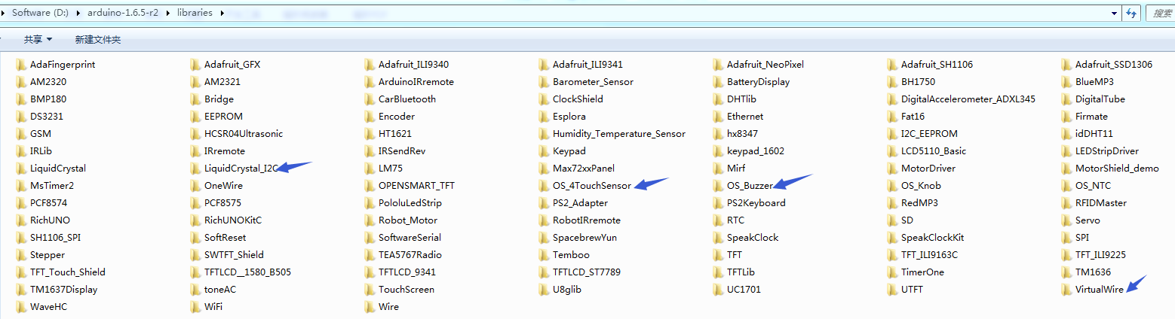

**Pins wiring guide**

|  |  |  |
| --- | --- | --- |
|  |  | IO Expansion Shield  (Plug onto OPEN-SMART UNO R3) |
| Receiver Module (rectangle shape) | SIG | D2 |
| VCC | VCC |
| GND | GND |
| I2C 1602 LCD | SCL | SCL |
| SDA | SDA |
| VCC | VCC |
| GND | GND |